***Name: Parth Thoriya***

Image Number 1: Business Development

********** HTML CODE ********************

<!DOCTYPE html>

<html>

<head>

<meta charset="utf-8">

<meta name="viewport" content="width=device-width, initial-scale=1">

<title>Box Model 1</title>

<link rel="stylesheet" type="text/css" href="style1.css">

</head>

<body>

<div class="box">

<h1 class="title">Business Development</h1>

<p>Have an idea or inquiry for Waze business development?</p>

<button class="btn"> Share your ideas</button>

</div>

</body>

</html>

***************** CSS CODE *********************

.box{

width: 500px;

background-image: linear-gradient(cyan ,darkcyan);

margin: 200px auto;

padding: 70px;

font-family: sans-serif;

border-radius: 10px;

box-sizing: border-box;

}

.title{

font-size: 40px;

}

.btn{

background-color: white;

border: none;

border-radius: 30px;

font-size: 20px;

margin-top: 15px;

font-weight: 600;

padding: 10px;

}

**************** OUPUT ********************

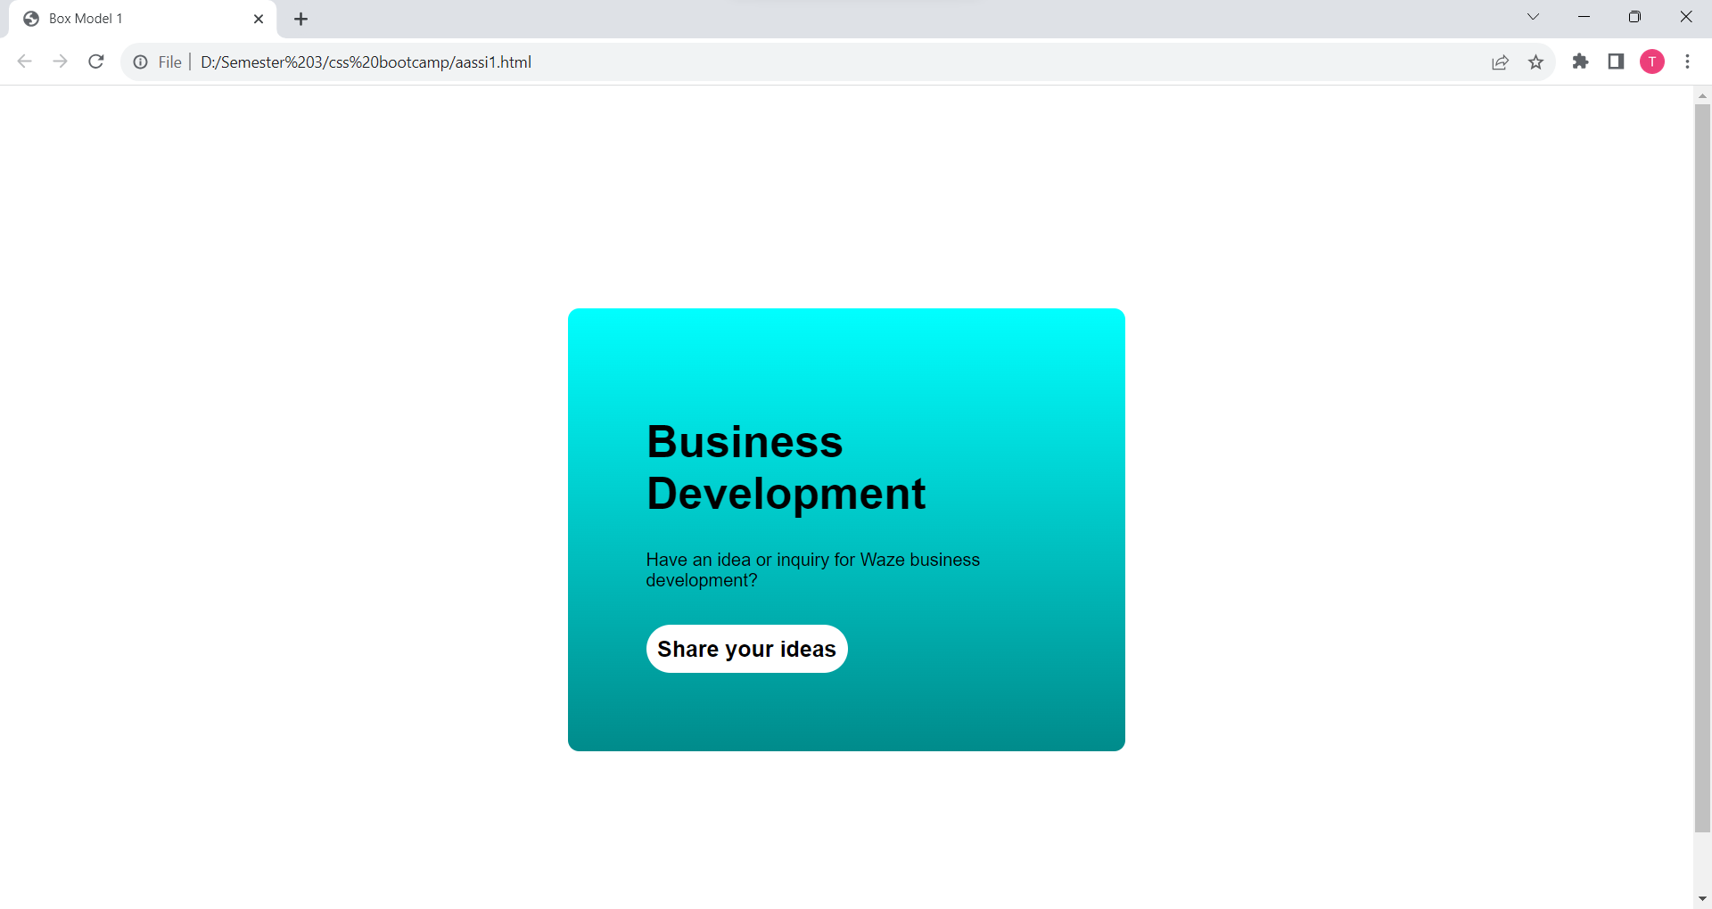

Image Number 2: Your Profile

********** HTML CODE ********************

<!DOCTYPE html>

<html>

<head>

<meta charset="utf-8">

<meta name="viewport" content="width=device-width, initial-scale=1">

<title>Box Model -2</title>

<link rel="stylesheet" type="text/css" href="style2.css" />

</head>

<body>

<div class="card">

<div class="card-body">

<div class="card-title">

<h3>Your profiles</h3>

</div>

<div>

<p>See how your profiles appear in Google services</p>

</div>

</div>

<div>

<img src="./profile1.png" class="profile" />

<img src="./profile3.jpg" class="profile" />

</div>

<div style="clear: both;"></div>

<div class="card-footer">

<a href="#" class="link-profile">See profiles</a>

</div>

</div>

</body>

</html>

***************** CSS CODE *********************

.card{

width: 550px;

margin: 100px auto;

font-family: sans-serif;

box-sizing: border-box;

border: 2px solid lightgray;

border-radius: 10px;

}

.card-body{

box-sizing: border-box;

padding: 25px;

}

.card-title{

font-size: 30px;

font-weight: 100;

}

.profile{

width: 100px;

float: left;

margin-left: 40px;

margin-bottom: 40px;

border-radius: 50%;

}

.card-footer{

border-top: 2px solid lightgray;

padding: 20px;

}

.link-profile{

text-decoration: none;

}

**************** OUPUT ********************

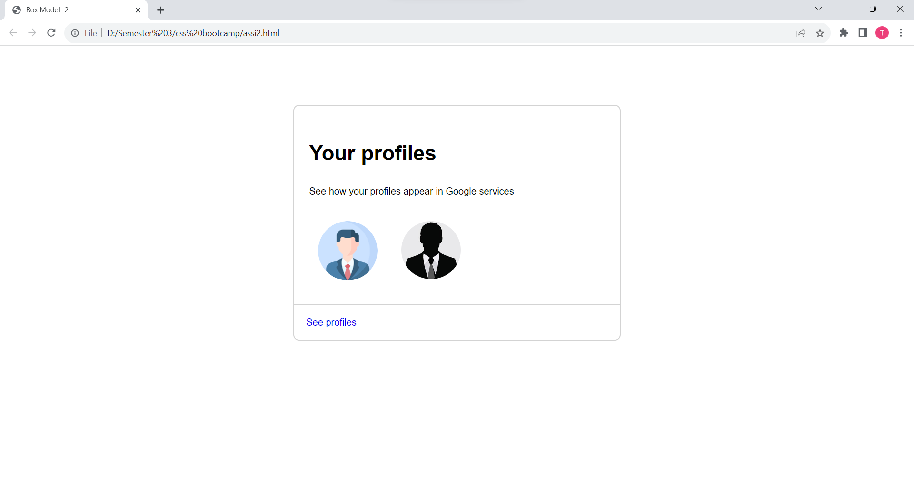

Image Number 3: Your Profile

********** HTML CODE ********************

<!DOCTYPE html>

<html>

<head>

<meta charset="utf-8">

<meta name="viewport" content="width=device-width, initial-scale=1">

<title>Box Model - 3</title>

<link rel="stylesheet" type="text/css" href="style3.css" />

</head>

<body>

<div class="card">

<div>

<img src="googlephoto.jpg" class="card-img" />

</div>

<div class="card-body">

<div>

<div class="small-img">

<img src="lock.png" class="img" />

</div>

<p>SUBSCRIBE TO ANY PLAN</p>

</div>

<div class="card-title">

<h3>Get more features in Google Photos</h3>

</div>

<div class="card-text">

<p>

Bring your favorite moments to life with more Google Photos editing tools for Android and iOS, including Magic Eraser. Subject to eligibility.

</p>

</div>

<button class="btn"> View details</button>

</div>

</div>

</body>

</html>

***************** CSS CODE *********************

.card{

width: 450px;

margin: 100px auto;

border: 1px solid lightgray;

border-radius: 10px;

font-family: sans-serif;

}

.small-img{

float: left;

width: 15px;

margin-right: 10px;

}

.img{

width: 100%;

}

.card-img{

width: 100%;

border-top-left-radius: 10px;

border-top-right-radius: 10px;

}

.card-body{

padding: 20px;

}

.card-title{

font-size: 24px;

}

.card-text{

color: gray;

}

p{

color: gray;

}

.btn{

padding: 10px;

background-color: white;

border: 1px solid lightgray;

color: blue;

font-size: 15px;

border-radius: 5px;

}

**************** OUPUT ********************

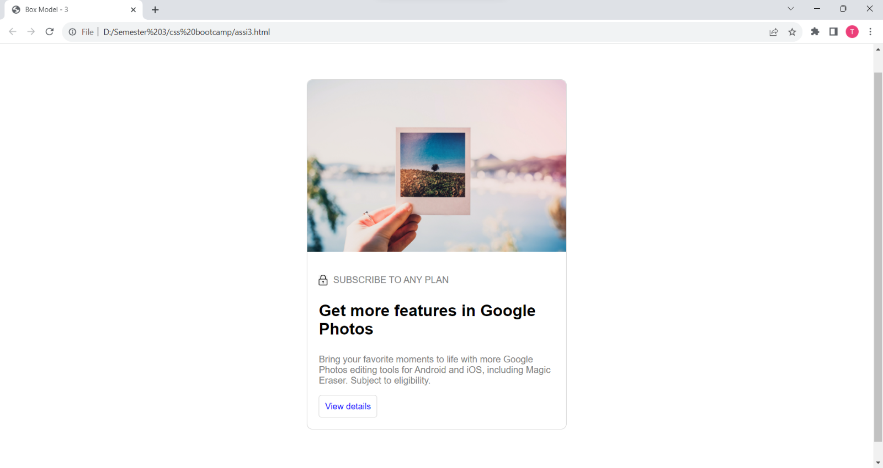

Image Number 2: Your Profile

********** HTML CODE ********************

<!DOCTYPE html>

<html>

<head>

<meta charset="utf-8">

<meta name="viewport" content="width=device-width, initial-scale=1">

<title>Box Model-4</title>

<link rel="stylesheet" type="text/css" href="style4.css" />

</head>

<body>

<div class="card">

<div class="card-img">

<img src="flodesk.png" class="img" />

</div>

<div class="card-title">

<h5>Welcome back!</h5>

</div>

<div>

<input type="text" placeholder="Enter your email" class="input" />

<input type="password" placeholder="Enter your password " s class="input"/>

</div>

<div class="div-btn">

<button class="btn">

Log in to Flodesk

</button>

</div>

<div class="card-link">

<span>

<a href="#" class="link-noline">Not a member?</a>

</span>

<span>

<a href="#" class="link">Sign up</a>

</span>

<br/>

<span>

<a href="#" class="link">Forgot your password?</a>

</span>

</div>

<div class="card-footer">

<p>

By continuing, you agree to Flodesk's

<a href="#" class="footer-link">terms</a>

and acknowledge you've read our

<a href="#" class="footer-link">privacy policy</a>

</p>

</div>

</div>

</body>

</html>

***************** CSS CODE *********************

.card{

width: 500px;

margin: 100px auto;

padding: 40px;

font-family: sans-serif;

text-align: center;

}

.card-title{

width: 100%;

font-size: 25px;

font-weight: 600;

text-align: center;

}

.input{

width: 100%;

margin-bottom: 10px;

padding: 15px;

border-radius: 10px;

border: 1px solid lightgray;

}

.btn{

border: none;

padding: 15px;

padding-left: 50px;

padding-right: 50px;

margin: 20px;

font-size: 18px;

background-color: black;

color: white;

border-radius: 40px;

text-align: center;

}

.link-noline{

text-decoration: none;

color: gray;

}

.link{

color: black;

}

.card-link{

margin: 10px;

padding: 10px;

}

.card-footer{

margin: 20px;

color: gray;

}

.footer-link{

color: gray;

}

**************** OUPUT ********************

